Phone: - 49233982

GENERAL SUPPLY CORPORATION
Amit G. Parikh
Mobile:-9869905779 ® 45242910
GSTIN-27ACJPP2955J1Z4

Shaumitra G Parikh
Mobile:- 9821361314 , 8369398586 ® 35989674
GSTIN-27AAGPP1621C1Z5

S . K U M A R & B R O S .
3rd Central Building , Grd. Flr. , 11 , Bomanji Master Road , Mumbai :- 400 002.
INSULATING -:- ELECTRICALS -:- ELECTRONIC -:- HARDWARE -:- MATERIALS
Empire , Fibreglass , Cotton , Silicon , Teflon , P.V.C. , Heatshinkable , etc. TUBE , CABLE , WIRE , CLOTH , TAPE .
Solder Items , Paste , Tester , Fuse Wire , All Cord Wires, Iron Element , T.V. & Cable Plug , Socket , Pin , & Splitter
Prices List :- GSC / 2025 . Estd. :-1962 SK/2025. Estd.1991. Dt. :- 1ST. MAY 2025.
Sr.No. | P A R T I C U L A R S | Size | LIST | PER | Sr.No. | P A R T I C U L A R S |  | ID Size |  | LIST | PER
1. | ART SILK TUBE / Sleeves | 1mm | 280.00 | 100mtr. | 71. | PVC CORD IN BLACK , GREY Colour |  | 0.5mm |  | 120.00 | 100mtr.
2. | HSN Code - 85469090 | 2mm | 380.00 | ’’ | 72. | PVC PIPES IN BLACK, RED, BLUE, YELLOW , |  | 0.5mm |  | 120.00 | ’’
3. |  | 3mm | 600.00 | ’’ | 73. | GREEN, WHITE GREY Colour |  | 1.0mm |  | 130.00 | ’’
4. | 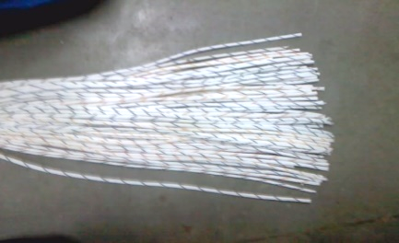 | 4mm | 760.00 | ’’ | 74. | HSN Code- 39173210 |  | 1.5mm |  | 140.00 | ’’
5. |  | 5mm | 860.00 | ’’ | 75. | 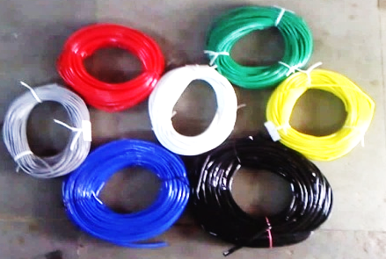 |  | 2.0mm |  | 150.00 | ’’
6. |  | 6mm | 1060.00 | ’’ | 76. |  |  | 2.5mm |  | 200.00 | ’’
7. |  | 8mm | 1780.00 | ’’ | 77. |  |  | 3.0mm |  | 90.00 | 30mtr.
8. |  | 10mm | 2000.00 | ’’ | 78. |  |  | 4.0mm |  | 110.00 | ’’
9. | FIBREGLASS “B” CLASS YELLOW TUBE | 1mm | 320.00 | ’’ | 79. |  |  | 5.0mm |  | 150.00 | ’’
10. | HSN Code - 85469090 | 2mm | 440.00 | ’’ | 80. |  |  | 6.0mm |  | 170.00 | ’’
11. |  | 3mm | 580.00 | ’’ | 81. |  |  | 7.0mm |  | 210.00 | ’’
12. |  | 4mm | 700.00 | ’’ | 82. |  |  | 8.0mm |  | 230.00 | ’’
13. |  | 5mm | 860.00 | ’’ | 83. |  |  | 10.0mm |  | 300.00 | ’’
14. |  | 6mm | 1060.00 | ’’ | 84. |  |  | 12.0mm |  | 380.00 | ’’
15. | 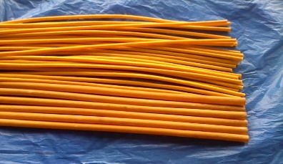 | 8mm | 1420.00 | ’’ | 85. |  |  | 14.0mm |  | 460.00 | ’’
16. |  | 10mm | 1820.00 | ’’ | 86. | 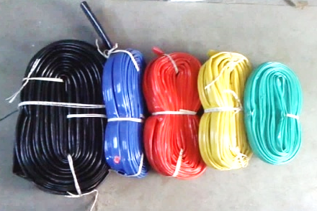 |  | 16.0mm |  | 500.00 | ’’
17. |  | 12mm | 2480.00 | ’’ | 87. |  |  | 18.0mm |  | 630.00 | ’’
18. |  | 16mm | 3340.00 | ’’ | 88. |  |  | 20.0mm |  | 700.00 | ’’
19. |  | 20mm | 5000.00 | ’’ | 89. |  |  | 22.0mm |  | 840.00 | ’’
20. |  | 25mm | 7000.00 | ’’ | 90. |  |  | 25.0mm |  | 960.00 | ’’
21. | FIBREGLASS “B” CLASS WHITE SPECIAL TUBE | 1mm | 380.00 | ’’ | 91. |  |  | 30.0mm |  | 1300.00 | ’’
22. | HSN Code - 85469090 | 2mm | 427.50 | ’’ | 92. |  |  | 35.0mm |  | 1800.00 | ’’
23. |  | 3mm | 522.50 | ’’ | 93. |  |  | 40.0mm |  | 1920.00 | ’’
24. |  | 4mm | 665.00 | ’’ | 94. |  |  | 45.0mm |  | 2200.00 | ’’
25. |  | 5mm | 760.00 | ’’ | 95. |  |  | 50.0mm |  | 2400.00 | ’’
26. | 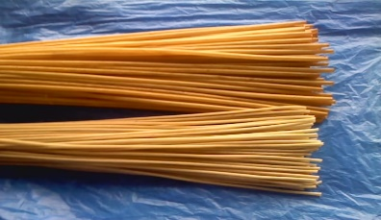 | 6mm | 950.00 | ’’ |  | P.V.C. HEAT SHINKABLE TUBE
27. |  | 8mm | 1425.00 | ’’ |  | HSN Code-39173100 Base Bar mm Size |  |  | L/F Size |  | Mtr.
28. |  | 10mm | 2375.00 | ’’ | 96. | 6 x 6 , 8 x 4 , 9 x 3 |  |  | 15/17mm | 9.00 | ’’
29. |  | 12mm | 2850.00 | ’’ | 97. | 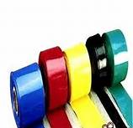  9 x 6 , 12 x 3 |  |  | 20/22mm | 9.20 | ’’
30. |  | 16mm | 3800.00 | ’’ | 98. | 12 x 6 , 15 x 3 |  |  | 25/27mm | 9.90 | ’’
31. |  | 20mm | 4750.00 | ’’ | 99. | 20 x 3, 4, 16 x 3 , 18 x 6 |  |  | 30mm | 10.80 | ’’
32. |  | 25mm | 5700.00 | ’’ | 100. | 20 x 6, 25 x 3 |  |  | 35mm | 11.00 | ’’
33. | FIBREGLASS “F” CLASS TUBE | 1mm | 200.00 | ’’ | 101. | 25 x 6, 10 |  |  | 41mm | 13.00 | ’’
34. | HSN Code - 85469090 | 2mm | 300.00 | ’’ | 102. | 25, 30 x 10, 12.5 |  |  | 48mm | 15.20 | ’’
35. |  | 3mm | 400.00 | ’’ | 103. | 38 x 9 , 12 |  |  | 55mm | 17.40 | ’’
36. |  | 4mm | 500.00 | ’’ | 104. | 38 x 12 , 40 x 10 |  |  | 61mm | 19.00 | ’’
37. | 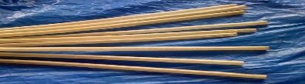 | 5mm | 600.00 | ’’ | 105. | 50 x 6 |  |  | 73mm | 22.80 | ’’
38. |  | 6mm | 800.00 | ’’ | 106. | 50 x 9 , 10 , 12 |  |  | 81mm | 25.60 | ’’
39. |  | 8mm | 1000.00 | ’’ | 107. | 60 x 10 , 12 & 75 x 6 |  |  | 93mm | 28.40 | ’’
40. |  | 10mm | 1400.00 | ’’ | 108. | 60 x 10 , 12 & 75 x 12 |  |  | 103mm | 33.80 | ’’
41. |  | 12mm | 2000.00 | ’’ | 109. | 90 x 6, 10 |  |  | 110mm | 36.80 | ’’
42. |  | 16mm | 2900.00 | ’’ | 110. | 100 x 6, 10 , 12 |  |  | 128mm | 43.00 | ’’
43. |  | 20mm | 4400.00 | ’’ | 111. | 100 , 110 x 6 , 10, 12 |  |  | 140mm | 44.00 | ’’
44. |  | 25mm | 5400.00 | ’’ | 112. | 115 x 6 , 10 |  |  | 150mm | 48.00 | ’’
45. | FIBREGLASS PVC COATED CHINA TUBE | 1mm | 150.00  20 | ’’ | 113. | 125 x 6 , 10 |  |  | 170mm | 54.00 | ’’
46. | HSN Code - 85469090 | 2mm | 200.00 | ’’ | 114. | 150 x 6 , 12 |  |  | 190mm | 60.00 | ’’
47. |  | 3mm | 300.00 | ’’ | 115. | 175 x 6 , 12 |  |  | 210mm | 68.00 | ’’
48. |  | 4mm | 400.00 | ’’ | 116. | 200 x 6 , 10 , 12 |  |  | 230mm | 74.00 | ’’
49. | 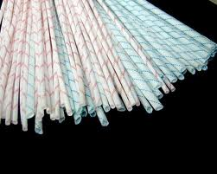 | 5mm | 500.00 | ’’ | 117. | SILICON RUBBER TUBE Size 1mm |  |  |  | 16.00 | Mtr.
50. |  | 6mm | 600.00 | ’’ | 118. | HSN Code-40094100 2mm |  |  |  | 20.00 | ’’
51. |  | 8mm | 800.00 | ’’ | 119. | 2.5mm |  |  |  | 28.00 | ’’
52. |  | 10mm | 1000.00 | ’’ | 120. | 3mm |  |  |  | 40.00 | ’’
53. |  | 12mm | 1200.00 | ’’ | 121. | 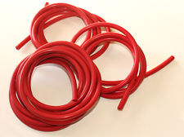  4mm |  |  |  | 54.00 | ’’
54. |  | 14mm | 2500.00 | ’’ | 122. | 5mm |  |  |  | 60.00 | ’’
55. |  | 16mm | 3000.00 | ’’ | 123. | 6mm |  |  |  | 78.00 | ’’
56. |  | 20mm | 4000.00 | ’’ |  | TEFLON TUBE | I.D.Size |  | O.D.Size |  | Mtr.
57. |  | 25mm | 5000.00 | ’’ | 124. | 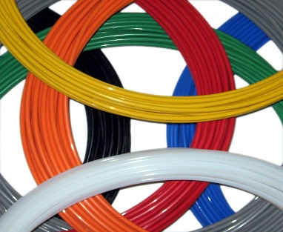  HSN Code-39172190 | 0.5mm |  | 1.0mm | 11.00 | ’’
58. | FIBREGLASS SILICON “H” CLASS CHINA TUBE | 1mm | 220.00 | ’’ | 125. |  | 1.0mm |  | 1.5mm | 13.00 | ’’
59. | HSN Code - 85469090 | 2mm | 300.00 | ’’ | 126. |  | 1.5mm |  | 2.0mm | 20.00 | ’’
60. |  | 3mm | 490.00 | ’’ | 127. |  | 2.0mm |  | 2.5mm | 28.00 | ’’
61. |  | 4mm | 610.00 | ’’ | 128. |  | 2.5mm |  | 3.0mm | 35.00 | ’’
62. |  | 5mm | 790.00 | ’’ | 129. |  | 3.0mm |  | 3.5mm | 50.00 | ’’
63. |  | 6mm | 960.00 | ’’ | 130. |  | 3.5mm |  | 4.0mm | 60.00 | ’’
64. |  | 8mm | 1410.00 | ’’ | 131. |  | 4.0mm |  | 5.0mm | 66.00 | ’’
65. | 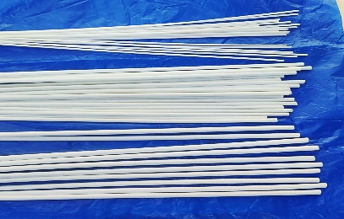 | 10mm | 1820.00 | ’’ | 132. |  | 5.0mm |  | 6.0mm | 96.00 | ’’
66. |  | 12mm | 2330.00 | ’’ | 133. |  | 6.0mm |  | 7.0mm | 110.00 | ’’
67. |  | 14mm | 4150.00 | ’’ | 134. |  | 7.0mm |  | 8.0mm | 124.00 | ’’
68. |  | 16mm | 5350.00 | ’’ | 135. |  | 8.0mm |  | 9.0mm | 166.00 | ’’
69. |  | 20mm | 7100.00 | ’’ | 136. |  | 9.0mm |  | 10.0mm | 194.00 | ’’
70. |  | 25mm | 8900.00 | ’’ | 137. |  | 10.0mm |  | 11.0mm | 250.00 | ’’
Cont’d Page 2.

GENERAL SUPPLY CORPORATION DT:-1ST MAY 2025 S. KUMAR & BROS. Page .
Sr.No. | P A R T I C U L A R S | HSN Code | List | Per | Sr.No. | P A R T I C U L A R S | HSN Code | List | Per
 |  |  |  |  |  |  |  |  | Pcs.
 |  |  |  |  |  |  |  |  | ,,
 |  |  |  |  |  |  |  |  | ,,
 |  |  |  |  |  |  |  |  | ,,
 |  |  |  |  |  |  |  |  | ,,
 |  |  |  |  |  |  |  |  | ,,
 |  |  |  |  |  |  |  |  | ,,
 |  |  |  |  |  |  |  |  | ,,
 |  |  |  |  |  |  |  |  | ,,
 |  |  |  |  |  |  |  |  | ,,
 |  |  |  |  |  |  |  |  | ,,
 |  |  |  |  |  |  |  |  | ,,
 |  |  |  |  |  |  |  |  | ,,
 |  |  |  |  |  |  |  |  | ,,
 |  |  |  |  |  |  |  |  | ,,
 |  |  |  |  |  |  |  |  | ,,
 |  |  |  |  |  |  |  |  | ,,
 |  |  |  |  |  |  |  |  | ,,
 |  |  |  |  |  |  |  |  | ,,
 |  |  |  |  |  |  |  |  | ,,
 |  |  |  |  |  |  |  |  | ,,
 |  |  |  |  |  |  |  |  | ,,
 |  |  |  |  |  |  |  |  | ,,
 |  |  |  |  |  |  |  |  | ,,
 |  |  |  |  |  |  |  |  | ,,
 |  |  |  |  |  |  |  |  | ,,
 |  |  |  |  |  |  |  |  | ,,
 |  |  |  |  |  |  |  |  | ,,
 |  |  |  |  |  |  |  |  | ,,
 |  |  |  |  |  |  |  |  | ,,
 |  |  |  |  |  |  |  |  | ,,
 |  |  |  |  |  |  |  |  | ,,
 |  |  |  |  |  |  |  |  | ,,
 |  |  |  |  |  |  |  |  | ,,
 |  |  |  |  |  |  |  |  | ,,
 |  |  |  |  |  |  |  |  | ,,
 |  |  |  |  |  |  |  |  | ,,
 |  |  |  |  |  |  |  |  | ,,
 |  |  |  |  |  |  |  |  | ,,
 |  |  |  |  |  |  |  |  | ,,
 |  |  |  |  |  |  |  |  | ,,
 |  |  |  |  |  |  |  |  | ,,
 |  |  |  |  |  |  |  |  | ,,
 |  |  |  |  |  |  |  |  | ,,
 |  |  |  |  |  |  |  |  | ,,
 |  |  |  |  |  |  |  |  | ,,
 |  |  |  |  |  |  |  |  | ,,
 |  |  |  |  |  |  |  |  | ,,
 |  |  |  |  |  |  |  |  | ,,
 |  |  |  |  |  |  |  |  | ,,
 |  |  |  |  |  |  |  |  | ,,
 |  |  |  |  |  |  |  |  | ,,
 |  |  |  |  |  |  |  |  | ,,
 |  |  |  |  |  |  |  |  | ,,
 |  |  |  |  |  |  |  |  | ,,
 |  |  |  |  |  |  |  |  | ,,
 |  |  |  |  |  |  |  |  | ,,
 |  |  |  |  |  |  |  |  | ,,
 |  |  |  |  |  |  |  |  | ,,
 |  |  |  |  |  |  |  |  | ,,
 |  |  |  |  |  |  |  |  | ,,
 |  |  |  |  |  |  |  |  | ,,
 |  |  |  |  |  |  |  |  | ,,
 |  |  |  |  |  |  |  |  | ,,
 |  |  |  |  |  |  |  |  | ,,
 |  |  |  |  |  |  |  |  | ,,
 |  |  |  |  |  |  |  |  | ,,
 |  |  |  |  |  |  |  |  | ,,
 |  |  |  |  |  |  |  |  | ,,
 |  |  |  |  |  |  |  |  | ,,
 |  |  |  |  |  |  |  |  | ,,
 |  |  |  |  |  |  |  |  | ,,
 |  |  |  |  |  |  |  |  | ,,
 |  |  |  |  |  |  |  |  | ,,
 |  |  |  |  |  |  |  |  | ,,
 |  |  |  |  |  |  |  |  | ,,
 |  |  |  |  |  |  |  |  | ,,

GENERAL SUPPLY CORPORATION DT:-1ST MAY 2025 S. KUMAR & BROS. Page 12
-: S P E C I A L M A T E R I A L P R I C E S O N R E Q U E S T :-

SLEEVING:- Empire , Cotton , Fiberglass , P.V.C. , Silicon , Teflon , Fixture , P.V.C. Heatsealing , China , etc.

TAPE:-Empire , Cotton , SuperFine , Webbing , Fiberglass , P.V.C. , Silicon , Teflon , Paper , Rubber etc.
CLOTH:- Empire , Varnish / Unvarnished FibreGlass , Teflon , etc.
CABLE:- FiberGlass , P.V.C. , Silicon , Teflon , etc.
WIRE:-Solder Wire & Stick , Nichrome , Kanthal , Eureka , Fuse Wire etc.
PAPAR & FILM:-Pressphan , Leatheriod , Nomax , ‘E’ Class , Kriple , Polyester Film , etc.
ROD, SHEET, TUBE:-Bakelite , Fabric base , RedFibre , Syndhanao , Glass Epoxy, etc.
ELECTRONIC ITEMS:- Neon Bulb , Resistances , Diode , Cords , Audio–Video Plug , Socket , Coupler , Adaptor etc.
TELEVISION & LAPTOP ITEMS:- PVC Wire , Plug , Cord , Cable Splitter , Cable jointer , etc.
HARDWARE:- Switch & Choke Patti Roma Box Screw & Nuts , Pliers , Screw Driver ,Tester , All types of Lugs etc.
ALL TYPE OF CORD:-Computer Cord , TV Cord , 2Pin & 3Pin Cord , Iron Cord , Printers Cord , Mobile Cord etc.
PROCELIEN ITEMS:-Connector , Halogen Holder , Bulb Holder , Nutrulink , Bus Bars , Beads , Tubes , Plates , etc.
P.V.C. SEALING MACHINCE:- Mica & Porcelain PVC Sealer Patti , Automatic Sealer Machine & Spare Parts etc.
CONNECTORS :- P.V.C. , Porcelain , Bakelite , ABS etc.
IRON & TOASTER ITMES :-‘U’ Element, Mica Element, Kettle Element , Stove ,Element , Thermostat , Plate , etc.
ELECTRICALS ACCESSERIES :-2Pin Top , 3Pin Top Multi Plug Male Female Plug, Iron Connector, Holder, Adaptors,
Junction Box , Conversion Plug , Stabilizer ,Voltage Conversion , etc.
LED TUBELIGHT ITEMS:-Patti , Adaptors. PL holder , SMPS etc.
SWITCHES :-
TELEPHONE ACCESSERIES:-Cords, Receivers Cord, Rossette box, Coupler, Plug Adaptors, Wires, Plier, Ringer, etc. INTERNET ACCESSERIES:-3 in 1 Plier, Patch Cord etc.
SOLDERING ITEMS:-Iron , Pot , Element , Bits , Stand, Paste, Liquid Paste, Desolder-wik, Wire, Stick, Pumps etc.
PANNEL BOARD ITEMS:-Cable Tie, Cable Tie Supportor, Twist Cord, PVC Box Channel, Cooling Fan “P” Clip,
Nail Clip , LED Indicator , Label Plate & Sticker, Marking Sleeve/Tube,Spiral Tube,
PVC Belt & Button PVC Ferrules etc.

Batteries:- Pencil AA-- AAA Cell ,Pager Cell 6V—9V—12V—24V Batteries

Blades & Cutter etc. :- Knief , Blade , Cutter etc.

Clamp Meter & Multi Meter :- China & Maco, Megher etc.

A S K F O R S P E C I A L I T E M S .
TERMS & CONDITIONS:-Prices are Ex-Godowns , S.T./ C.S.T. , Packing & Forwarding Extra.

Payment by Cash / Cheque / Mumbai D.D. / Document through Bank Only.

All Prices are Subject to Market Fluctuation & Changes without Notice

A S K F O R Q U A N T I T Y D I S C O U N T .

-: B O O K P O S T :-
From:-  M/s.  GENERAL SUPPLY CORPORATION  S. K u m a r s & B r o s.  3rd Central Building, Grd. Floor,  11, Bomanji Master Road,  Next to Kalbadevi Head Post Office,  Mumbai :- 400 002.  Office Phone :- 022 49233982  Mr. ShaumitraMobile :- 09821361314  :- 08369398586  Resi :- 022 3598 9674  Mr. Amit Mobile :- 09869905779  Resi :- 022 35989674 | To,  M/s.

